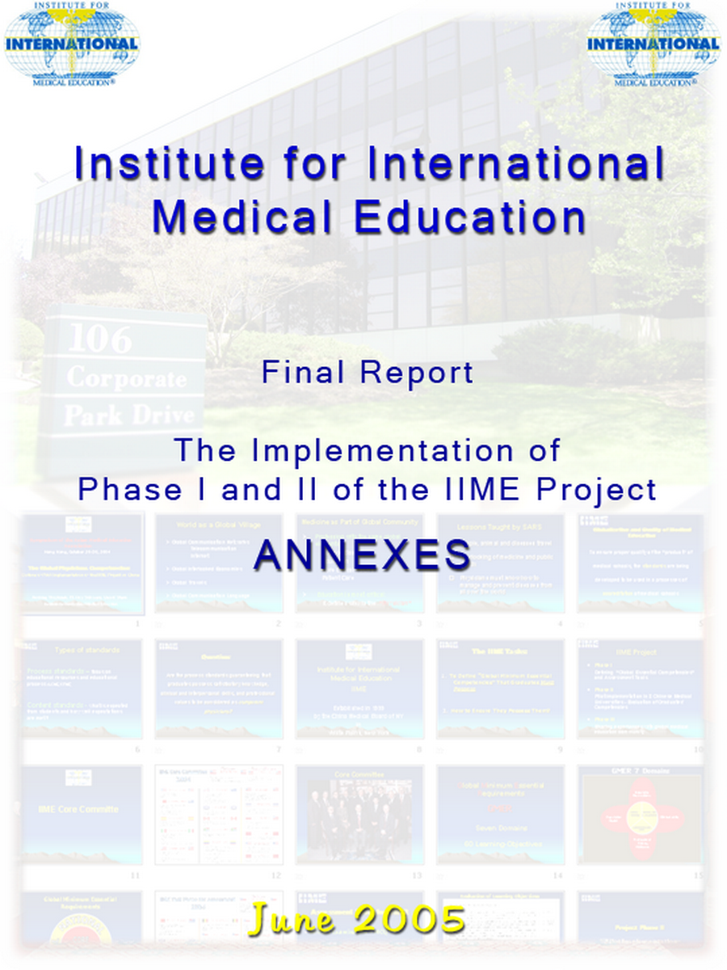
ANNEX 1.

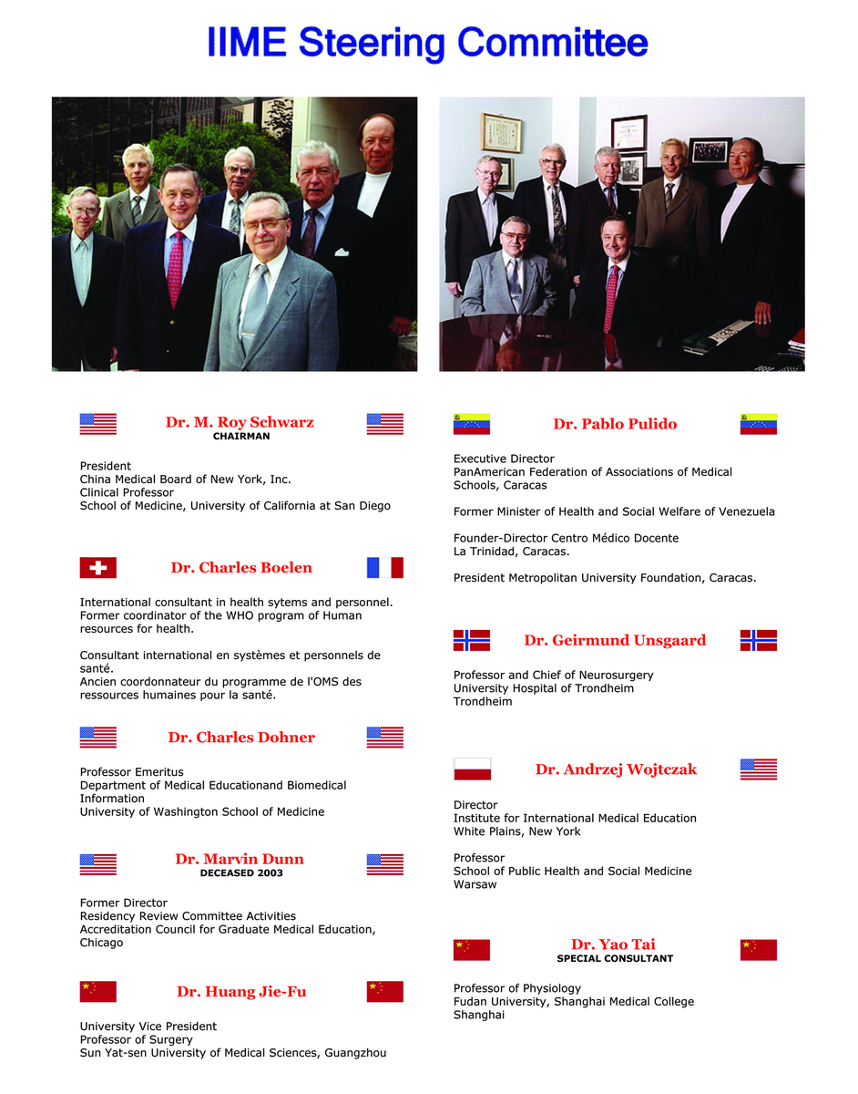

ANNEX 2.
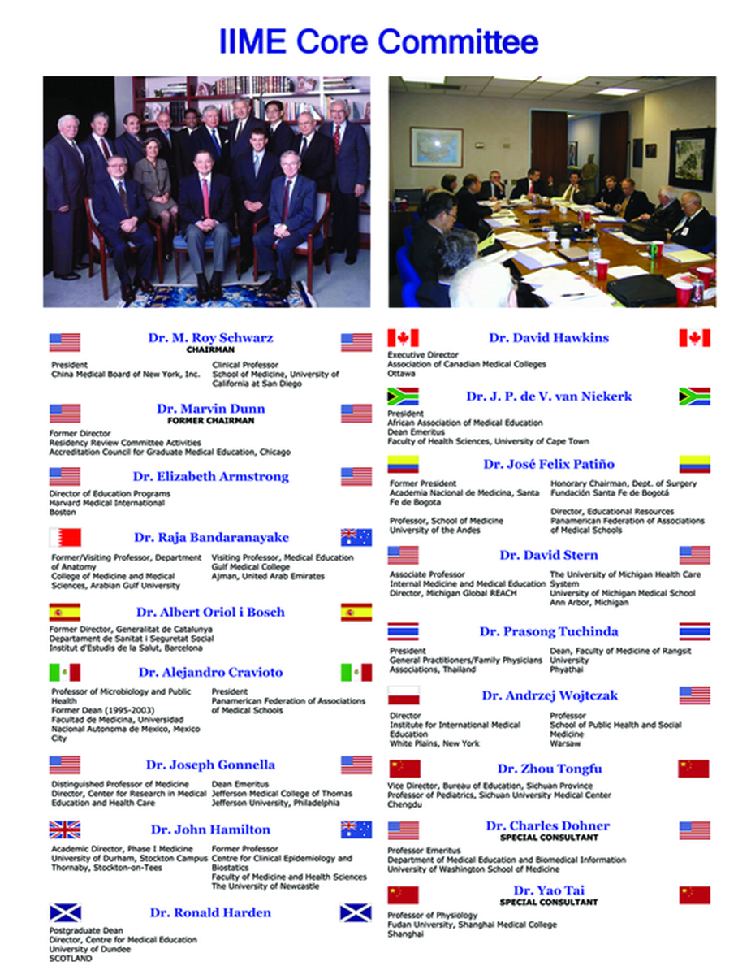

ANNEX 3.

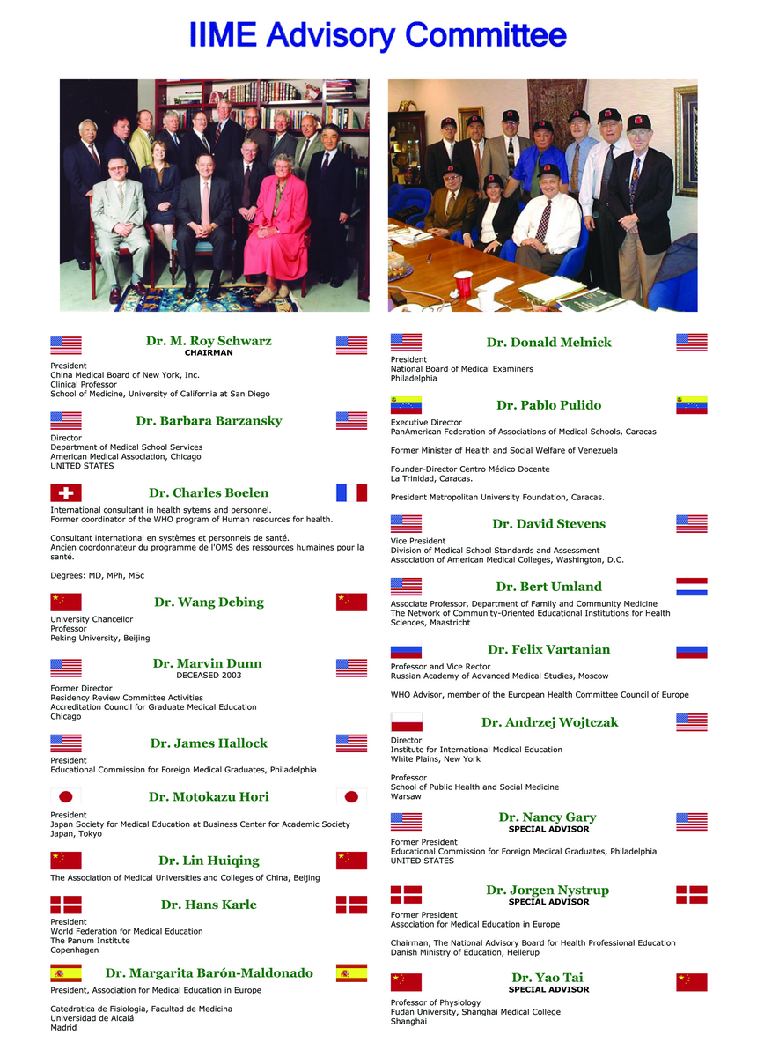
ANNEX 4.

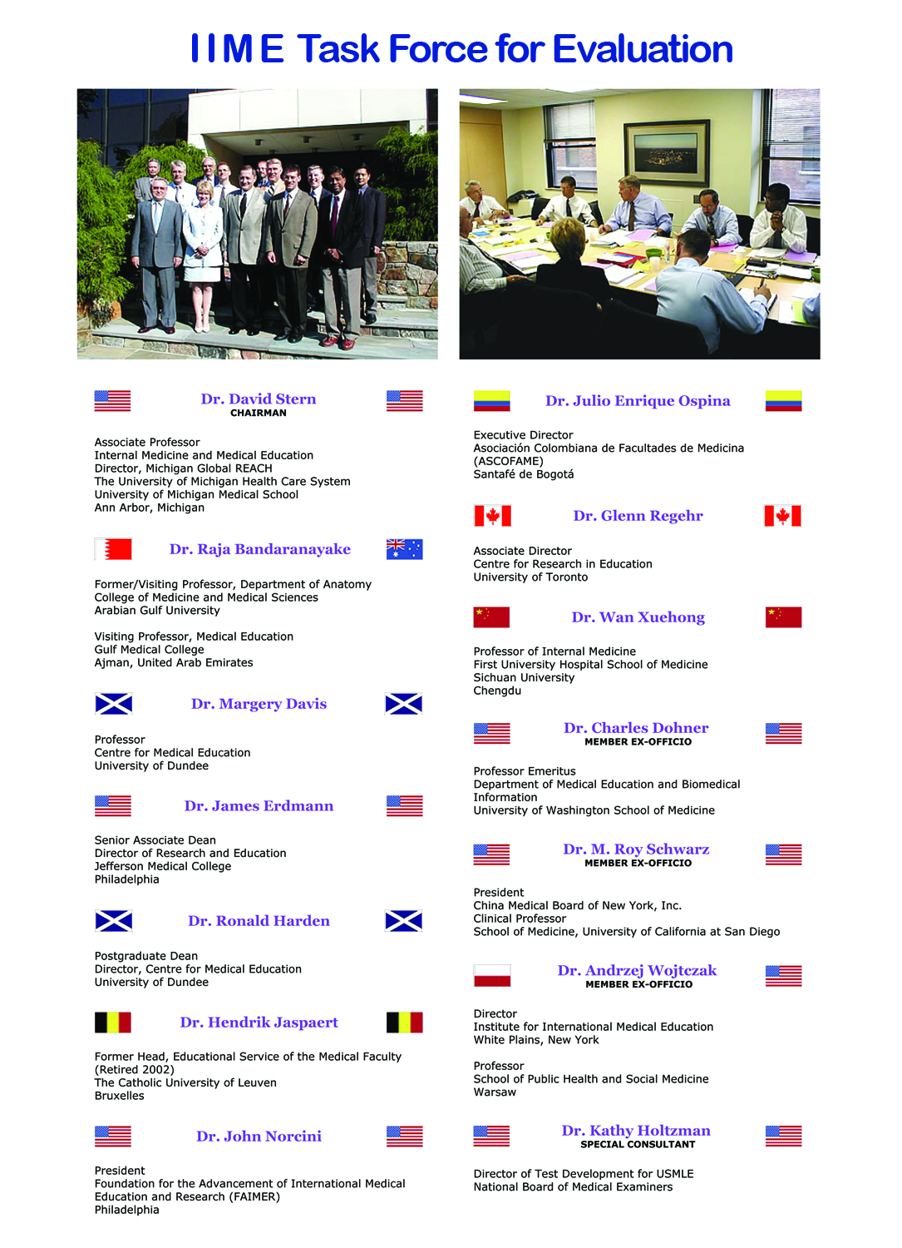
ANNEX 5.
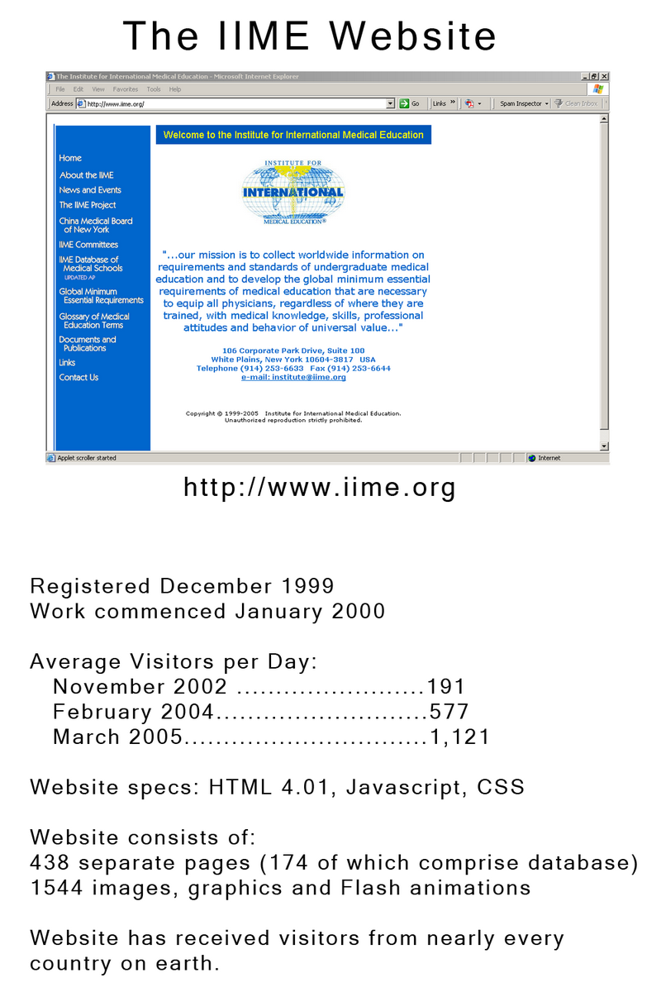

ANNEX 6.

GROUP MODERATORS

Professor Raja Bandaranayake
College of Medicine & Medical Sciences
Arabian Gulf University

Dr. Brian Hodges
Director of Assessment
University of Toronto

Ms. Kathleen Holtzman
Director of Test Material Development
National Board of Medical Examiners

Dr. David Stern
Director, Michigan Global REACH
University of Michigan

Professor Sun Bao Zhi
Director of Educational Center
China Medical University

Dr. David Swanson
Deputy Vice President for Test Development
National Board of Medical Examiners

Professor Wan Xuehong
Deputy Director
Dean’s Office, West China (Huaxi) Hospital
West China School of Medicine

Professor Yao Tai
Professor of Physiology
Fudan University Medical Center
ANNEX 7.

MEDICAL SCHOOL EXAM COORDINATORS

Professor Yi Luxi
Chief of Teaching Affairs Office
Xiangya School of Medicine
Central South University

Professor Sun Bao-Zhi, M.D.
Vice President for Academic Affairs
China Medical University

Professor Lu Yingqing, Vice Dean
Shanghai Medical College
Fudan University

Professor Guan Yuanzhi
Dean of Medical Education Administration
Peking Union Medical College

Professor Liu Yu-cun, Deputy Dean
First Clinical Medical School
Peking University Health Science Center

Professor Li Gandi, Vice Dean
Sichuan University School of Medicine

Dr. Zhang Ling, Deputy Director
Office of International Cooperation & Exchange
Sun Yat-Sen University

Professor Zhou Yu Ling, Deputy Director
Office of International Cooperation & Exchange
Xi'an Jiaotong University School of Medicine

ANNEX 8.

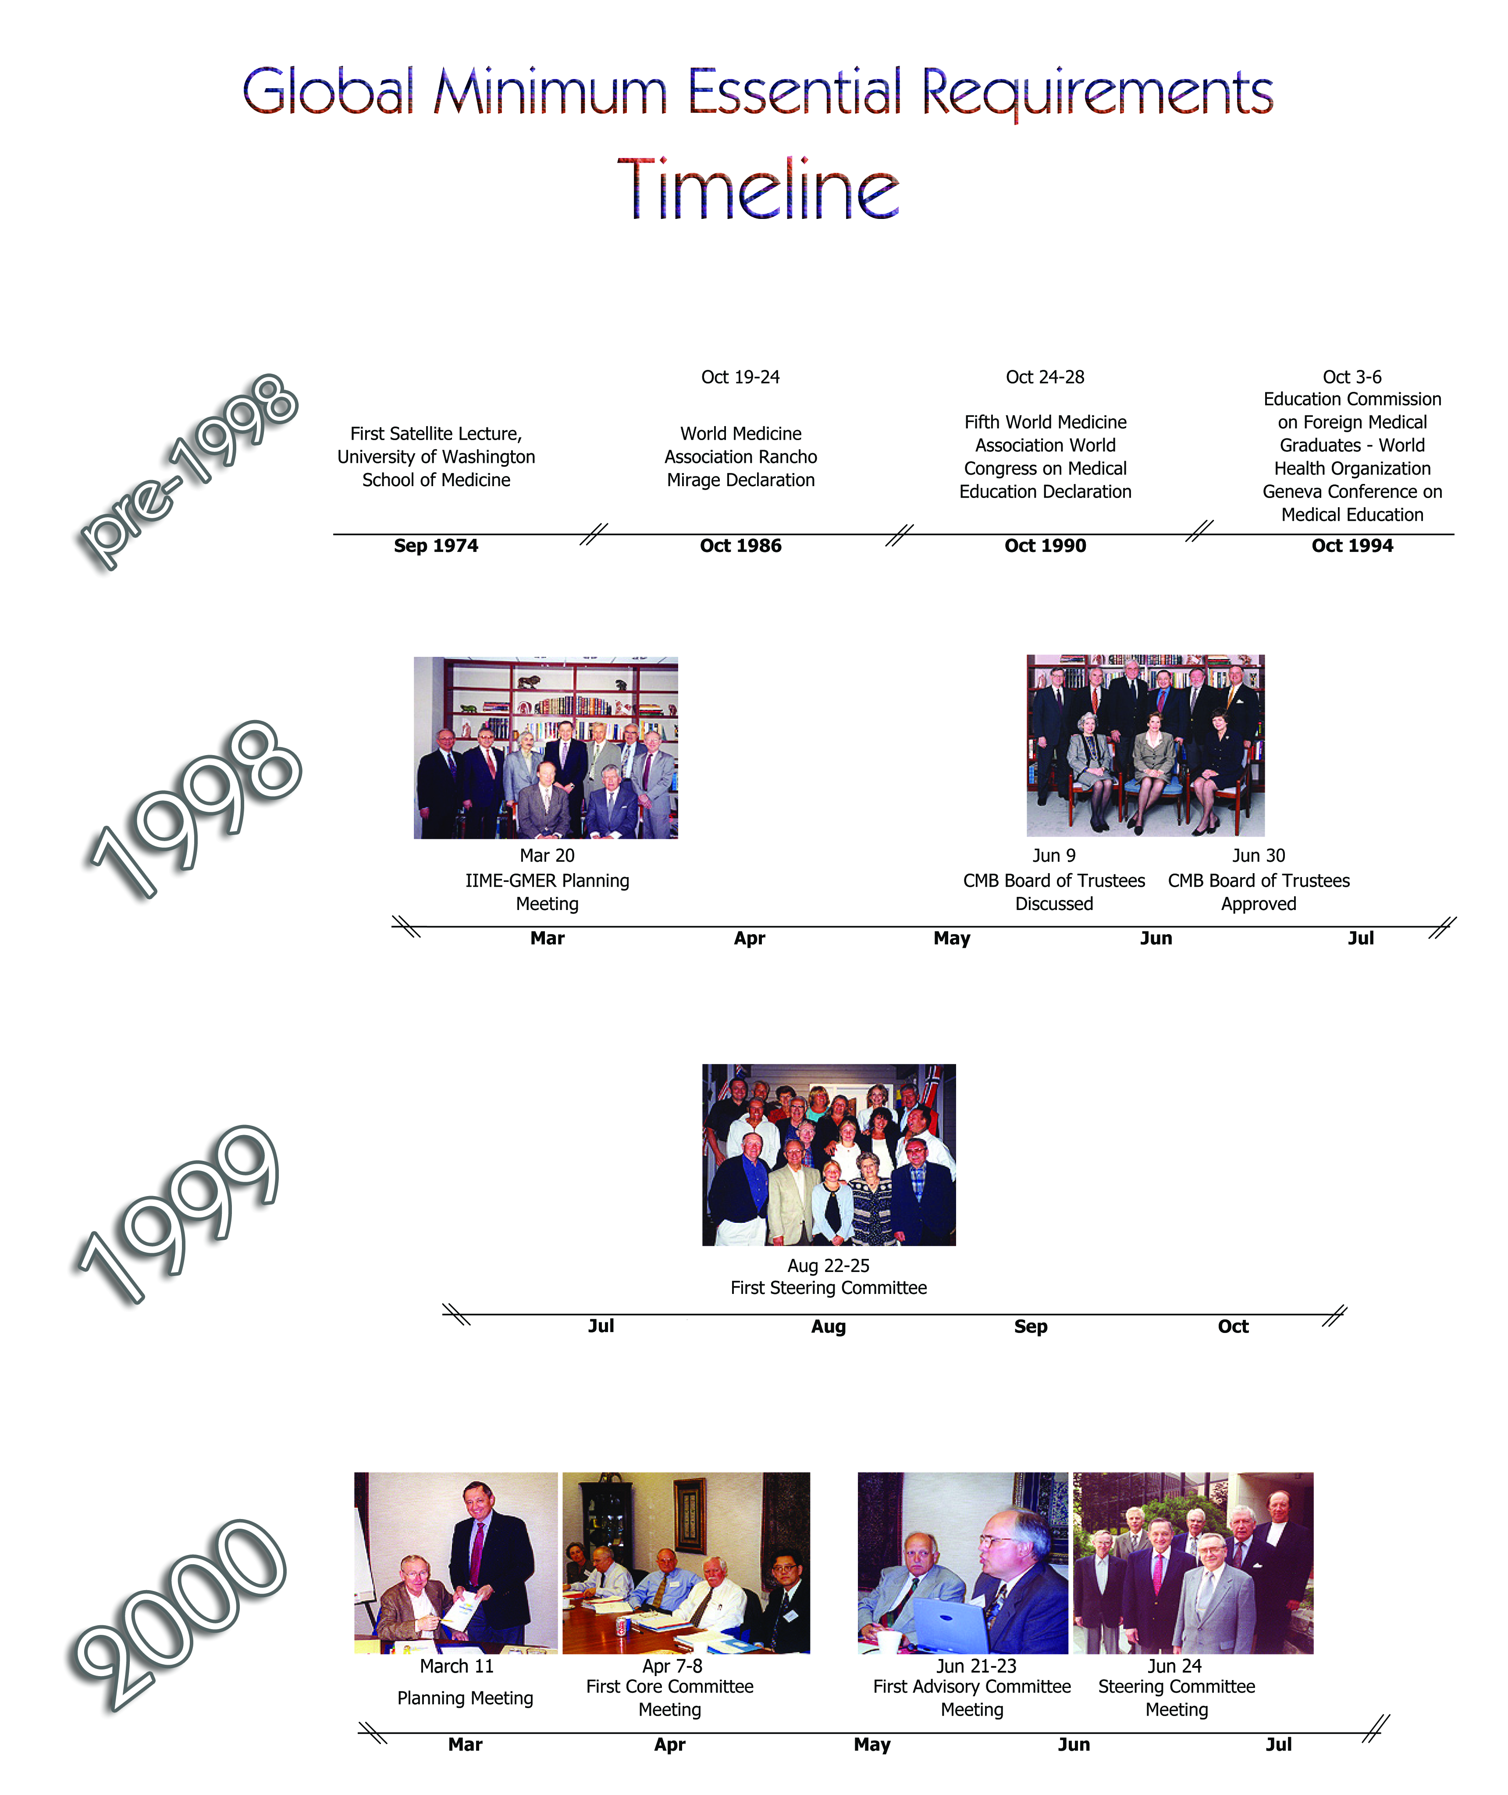

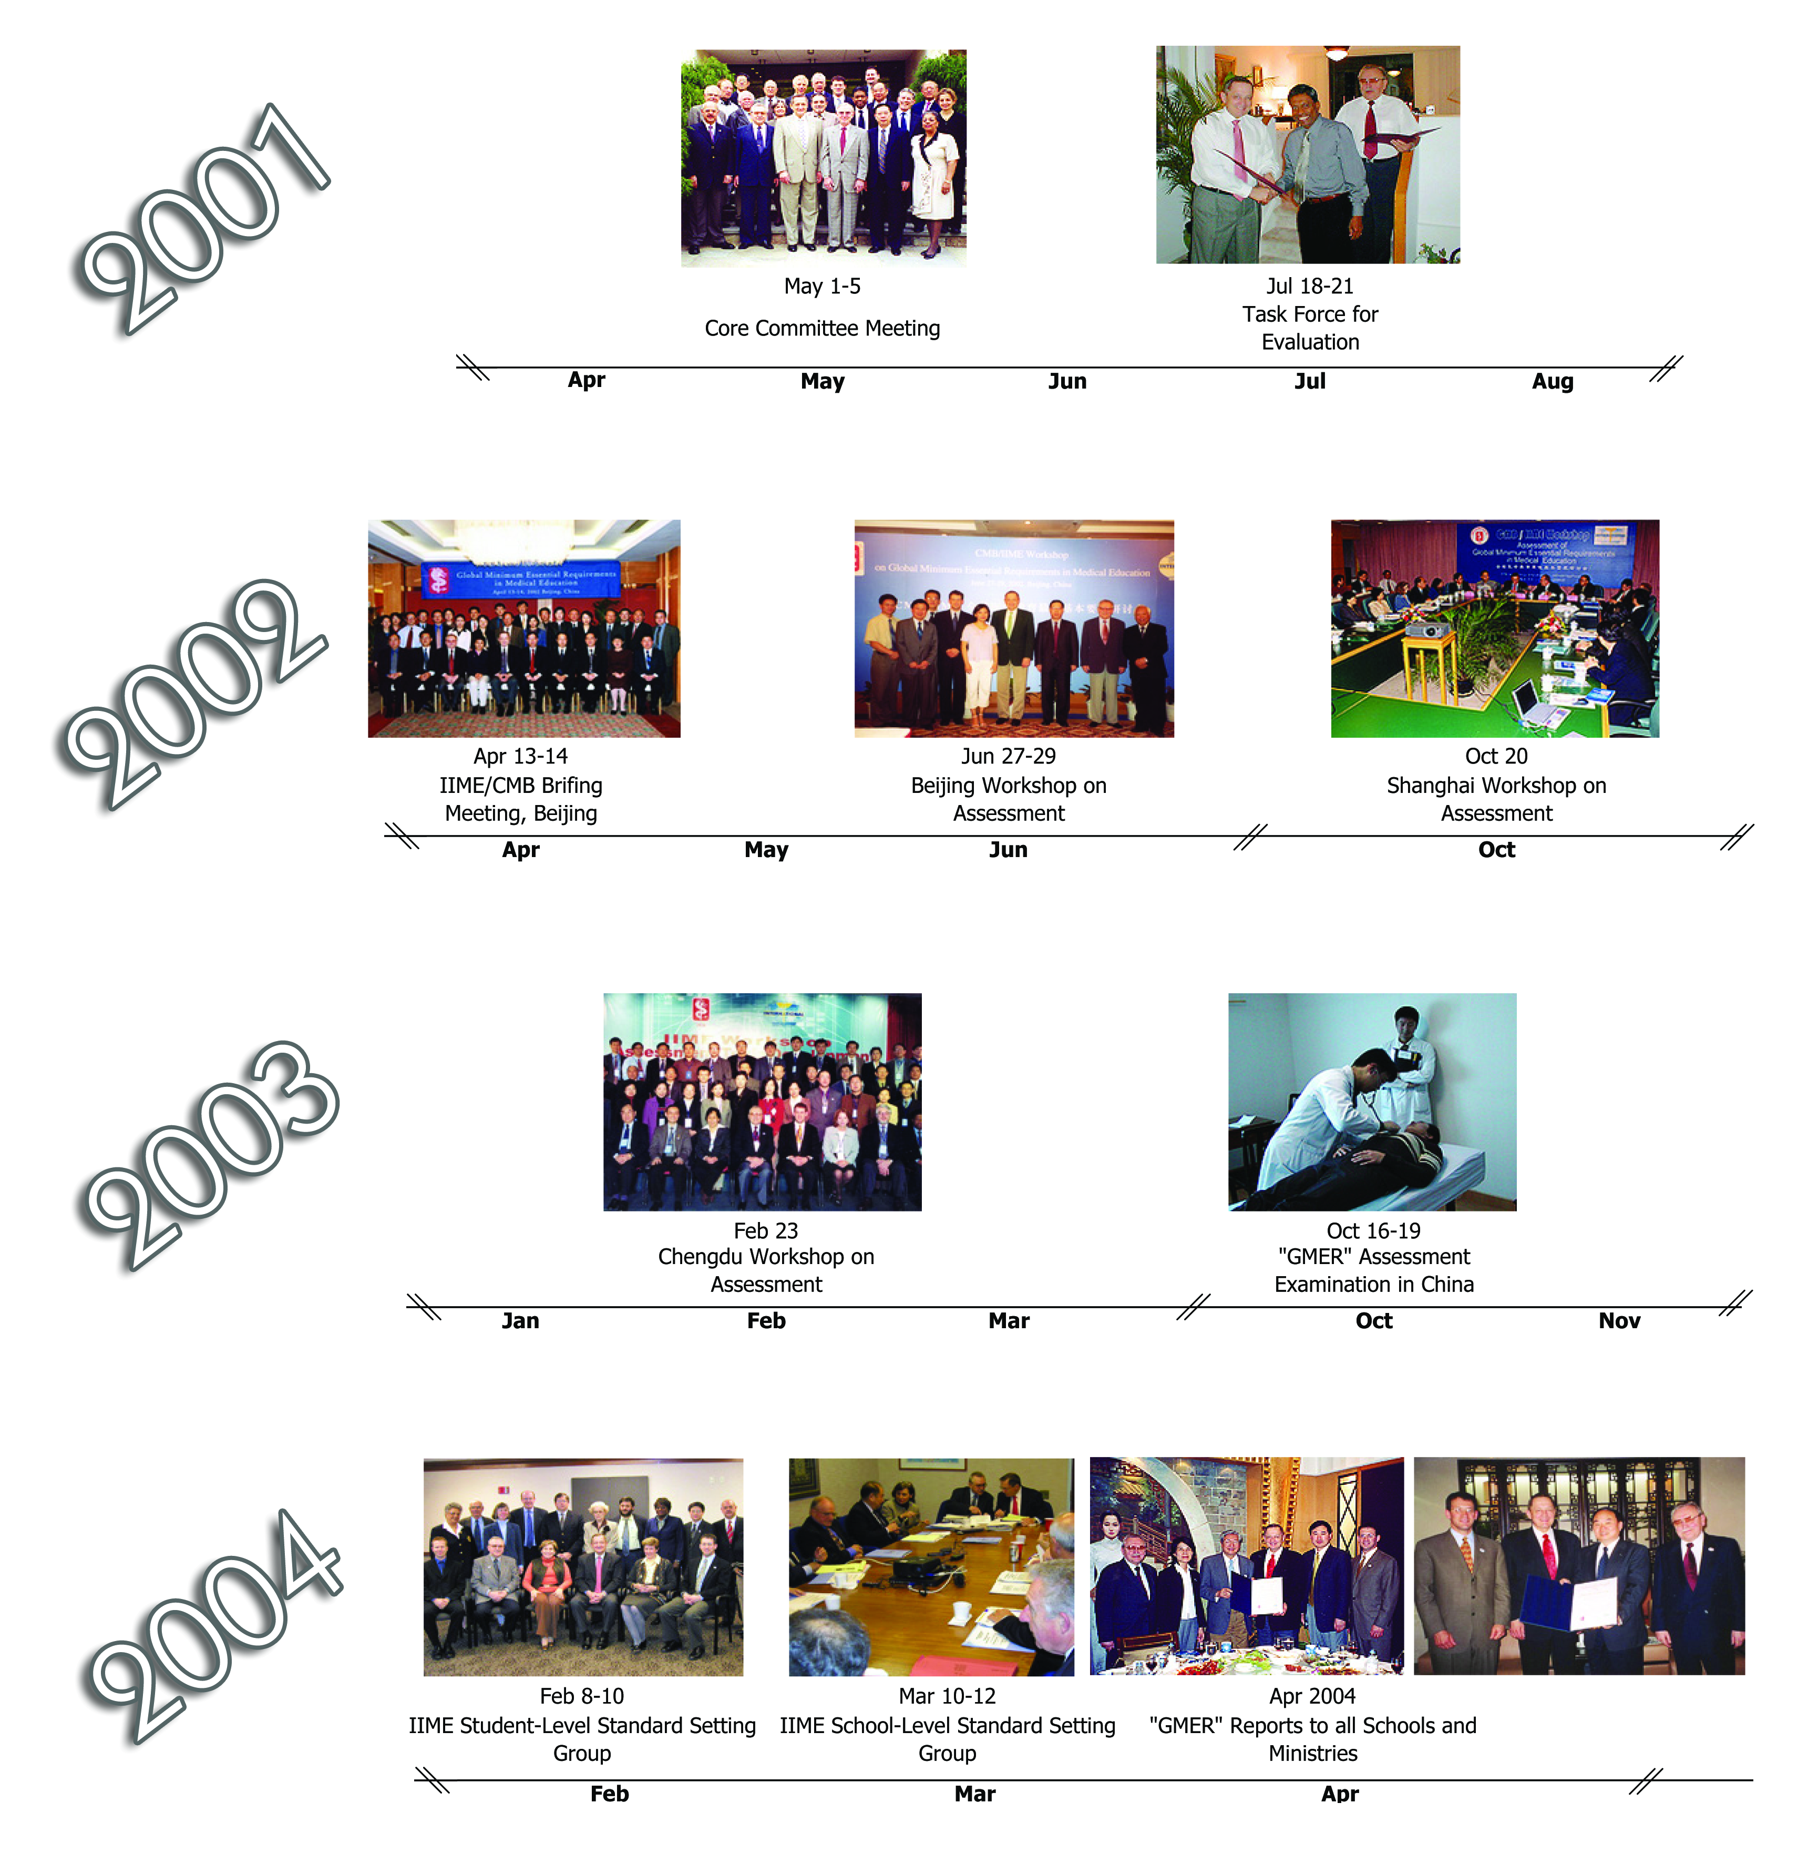

ANNEX 9.
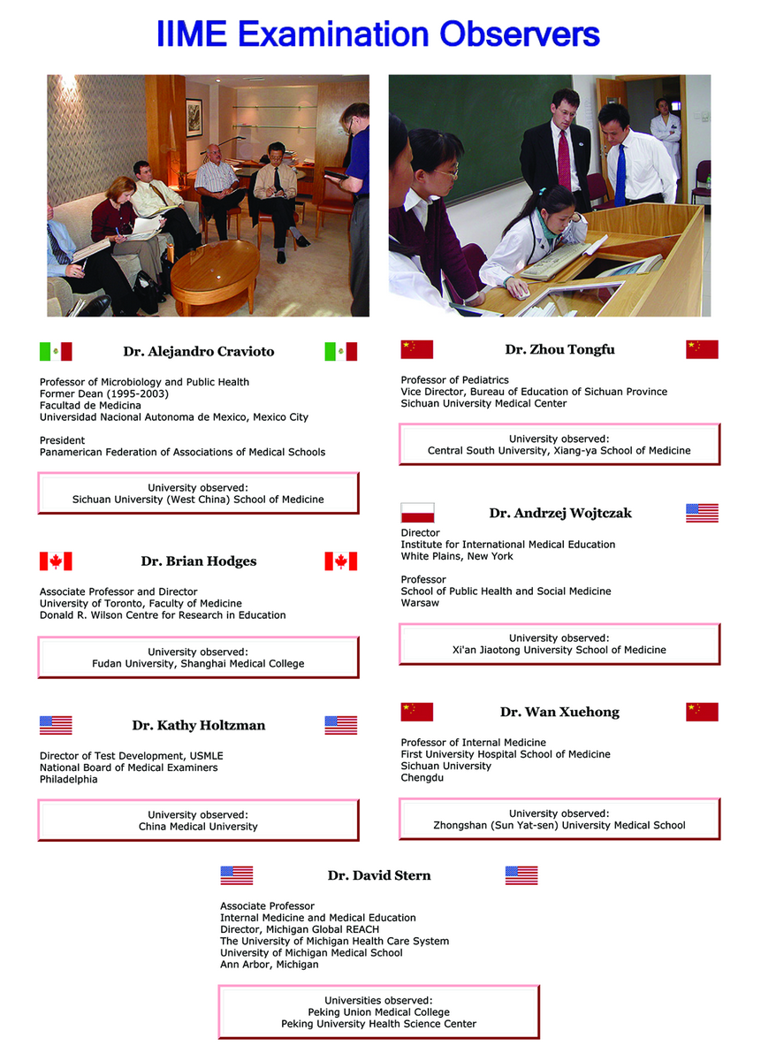
ANNEX 10.

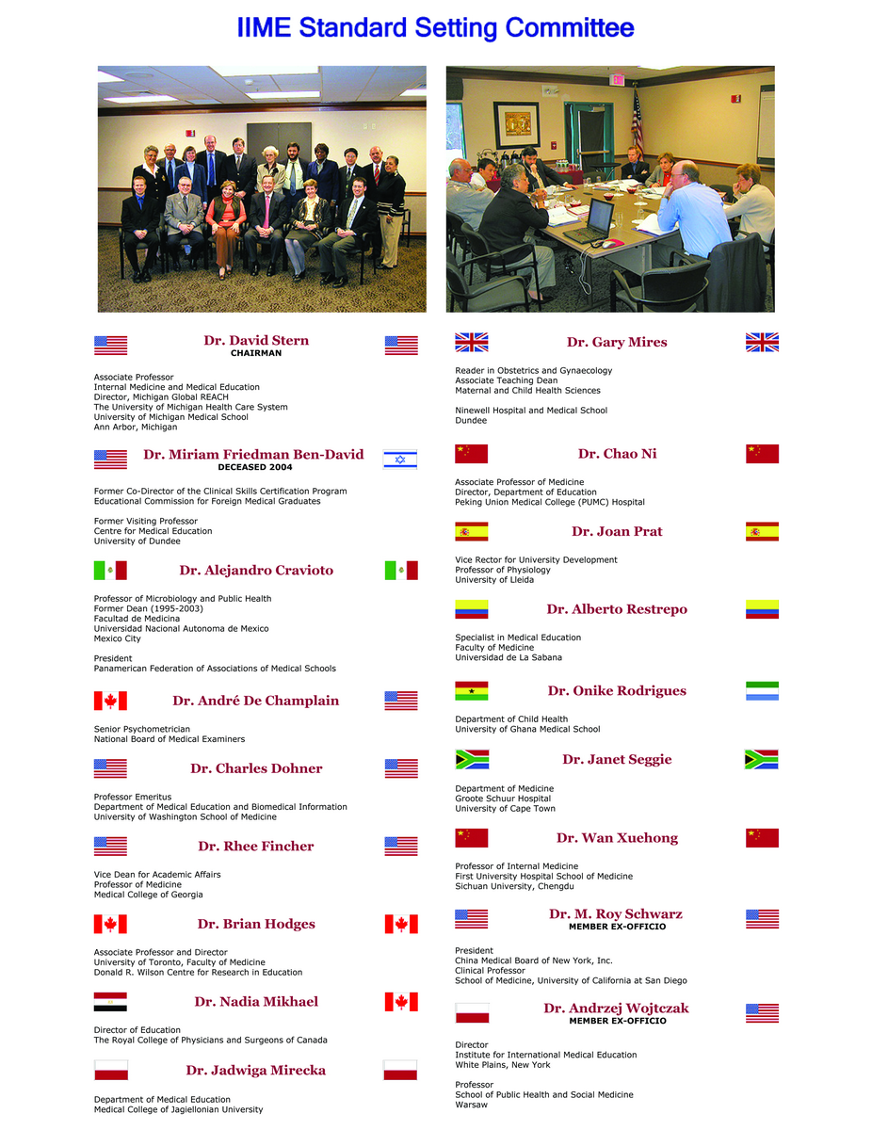
ANNEX 11-13.

Sample Student Report

Student name: «Student_name»
Student ID: «Student_ID»
School: «School»

Your IIME Examination Report contains three sections: Scores by IIME Domain, Scores by IIME Sub-domain, and Scores by discipline. For each row in each table, you will find that the scores are calculated from one or more of the assessments that you participated in last fall: Multiple Choice Questions (MCQ), Objective Structured Clinical Examination (OSCE), or faculty observations over three months. The mean score for all Chinese students who participated are provided in the next column. An international panel of medical experts met and reviewed all the test materials, providing a “cut score” above which an individual student is considered to meet minimum competency standard for that item. Your score is provided in the final column.

The purpose of this examination was primarily to evaluate the quality of your school, not your individual performance, so the accuracy of some of this information is not as high as would be expected if these scores were to be used for important decisions about your career. Particularly for the OSCE and faculty observations, some may actually be higher or lower because we observed your individual performance in only a limited number of settings, and the effects of observers can bias your score when few observations are recorded.

Section 1: IIME Domains
These are the domains reported to your school in aggregate, and help determine the degree with which your school meets the IIME international standard.

IIME Domain | How Measured | All Schools Mean Score | Cut Score | My Score
Professionalism | MCQ | X | 41% | «DOM1»
 | OSCE | X | 3.91 | «DOM2»
 | Faculty Observations | X | 3.64 | «DOM3»
Scientific Foundations | MCQ | X | 51% | «DOM4»
Communication Skills | OSCE | X | 3.82 | «DOM5»
 | Faculty Observation | X | 3.45 | «DOM6»
Clinical Skills | MCQ | X | 52% | «DOM7»
 | OSCE | X | 3.03 | «DOM8»
Population Health | MCQ | X | 54% | «DOM9»
Information Management | OSCE | X | 3.48 | «DOM10»
Scientific Thinking | Faculty Observation | X | 3.59 | «DOM11»

Sample Student Report (continued)

Section 2: IIME Sub-Domains

IIME Sub-Domains | How Measured | All Schools Mean Score | Cut Score | My Score
Scientific Foundations
Normal Structure and Function | MCQ | X | 52.2% | «SD1»
Abnormal Structure and Function | MCQ | X | 55.0% | «SD2»
Interventions in acute and chronic illness | MCQ | X | 58.2% | «SD3»
Communication Skills
Listen attentively to elicit information | OSCE | X | 3.82 | «SD4»
Apply communication skills, communicate effectively | OSCE | X | 3.64 | «SD5»
Clinical Skills
Take an appropriate history | OSCE | X | 3.79 | «SD6»
Perform a complete physical examination | OSCE | X | 3.03 | «SD7»
Perform a mental status examination | OSCE | X | 69.0% | «SD8»
Application of diagnostic procedures | MCQ | X | 50.3% | «SD9»
Exercise of clinical judgment | MCQ | X | 58.9% | «SD10»
Recognition and management of emergencies | MCQ | X | 61.5% | «SD11»
Recognition and management of emergencies | OSCE | X | 65.3% | «SD12»
Therapeutics | MCQ | X | 57.0% | «SD13»

Sample Student Report (continued)

Section 3: Disciplines

Disciplines | How Measured | All Schools Mean Score | Cut Score | My Score
Immunology and Hematology | MCQ | X | 52.6% | «DIS1»
Nervous system | MCQ | X | 62.3% | «DIS2»
Cardiovascular | MCQ | X | 61.6% | «DIS3»
Respiratory | MCQ | X | 63.1% | «DIS4»
Nutrition/Digestion | MCQ | X | 57.1% | «DIS5»
Endocrine and Reproductive | MCQ | X | 54.7% | «DIS6»
Renal and Urinary | MCQ | X | 51.7% | «DIS7»
Skin, Musculoskeletal and Connective Tissue | MCQ | X | 61.4% | «DIS8»
Internal Medicine - Knowledge | MCQ | X | 55.0% | «DIS9»
Internal Medicine - Clinical Skills | OSCE | X | 71.0% | «DIS10»
Internal Medicine - Examination Skills | OSCE | X | 65.5% | «DIS11»
Surgery - Knowledge | MCQ | X | 59.3% | «DIS12»
Surgery - Clinical Skills | OSCE | X | 64.0% | «DIS13»
Surgery - Examination Skills | OSCE | X | 71.5% | «DIS14»
Pediatrics - Knowledge | MCQ | X | 60.5% | «DIS15»
Pediatrics Clinical Skills | OSCE | X | 70.5% | «DIS16»
Obstetrics and Gynecology - Knowledge | MCQ | X | 53.9% | «DIS17»
Obstetrics and Gynecology - Clinical Skills | OSCE | X | 65.0% | «DIS18»
Psychiatry - Knowledge | MCQ | X | 57.5% | «DIS19»
Psychiatry - Clinical Skills | OSCE | X | 69.5% | «DIS20»
Psychiatry - Examination Skills | OSCE | X | 69.0% | «DIS21»

Sample School Report

School: Sample University

Your IIME Examination Report contains four sections: scores by International Domain, scores by International Sub-Domain, scores by Discipline, and correlations between your school examinations and the relevant IIME examination by discipline (in the case of schools who sent us internal exam scores). For each row in each table, you will find that the scores are calculated from one or more of the assessments that your school participated in last fall: Multiple Choice Questions (MCQ), Objective Structured Clinical Examination (OSCE), or faculty observations over three months. Most scores are based on a percent correct score (0 to 100%), some scores from the OSCE and faculty observations are on a 1 (low) to 5 (high) scale.

The average score for all Chinese students who participated are provided in the next column. The average score of your students are provided in the next column. An international panel of medical experts met and reviewed all the test materials, providing a “cut score” above which an individual student is considered to meet minimum competency standard for that item. The percentage of your students falling below the standard is in the next column.

For a subset of scores, an international panel of experts also identified the internationally acceptable failure rate for all students at a school. For example, 10% of students at one school may have scores below the international cut score. For this domain, the international experts may have identified a failure rate of 15% as acceptable. Therefore, this school would still be considered to have met the competency level for this domain. These values are listed only for Section 1, along with whether your school achieved this standard, was at the borderline, or could use improvement.

The purpose of this examination was primarily to evaluate the quality of your school, not individual student performance. Particularly for the OSCE and faculty observations, some scores may actually be higher or lower because we observed your individual performance in only a limited number of settings, and the effects of observers can bias your score when few observations are recorded.

Students at your school have been provided individual reports with their scores in each of these areas. Student reports do not contain information on other students or other schools in China, only the international standard cut score, so that students can determine if their performance falls above or below the international standard.
Sample School Report (continued)

Section 1: International Domains with Student and School-Level Standards

Domain | How Measured | All Schools Mean Score | My School Mean Score | International Cut Score | % of My Students Below International Cut Score | International Acceptable Failure Rate | International Standard Met, Borderline, or  Needs Improvement
Professionalism | MCQ | 58.0% | 54.8% | 41.0% | 27.6% | 24.2% | Borderline
 | OSCE | 4.64 | 4.59 | 3.91 | 0.0% | 9.2% | Met
 | Faculty Observation | 4.00 | 3.51 | 3.64 | 65.5% | 14.1% | Needs Improvement
Scientific Foundations | MCQ | 57.5% | 54.5% | 51.0% | 31.0% | 21.4% | Needs Improvement
Therapeutics | MCQ | 58.2% | 59.8% | 50.0% | 6.9% | 18.6% | Met
Communication Skills
Data Collection Skills | OSCE | 4.11 | 3.88 | 3.82 | 44.8% | 11.8% | Needs Improvement
Patient Communication Skills | OSCE | 4.23 | 4.12 | 3.64 | 6.9% | 13.2% | Met
 | Faculty Observation | 3.90 | 3.72 | 3.45 | 30.9% | 17.7% | Needs Improvement
Clinical Skills | MCQ | 59.1% | 60.1% | 52.0% | 13.2% | 12.3% | Borderline
 | OSCE | 4.23 | 4.06 | 3.03 | 0.0% | 10.0% | Met
Population Health | MCQ | 62.0% | 69.6% | 54.0% | 7.9% | 19.1% | Met
Information Management | OSCE | 4.31 | 4.69 | 3.50 | 5.3% | 9.6% | Met
Scientific Thinking | Faculty Observation | 3.91 | 3.39 | 3.59 | 60.5% | 15.5% | Needs Improvement

Sample School Report (continued)

Section 2: International Sub-Domains with Student-Level Standards

Sub-Domains | How Measured | All Schools Mean Score | My School’s Mean Score | International Cut Score | % of My Students Below International Cut Score
Scientific Foundations
Normal Structure and Function | MCQ | 54.7% | 52.1% | 52.2% | 48.3%
Abnormal Structure and Function | MCQ | 57.9% | 53.5% | 55.0% | 62.1%
Interventions in acute and chronic illness | MCQ | 58.7% | 55.7% | 58.2% | 75.9%
Clinical Skills
Take an appropriate history | OSCE | 4.33 | 4.19 | 3.79 | 2.5%
Perform a complete physical examination | OSCE | 4.23 | 4.14 | 3.03 | 0.0%
Perform a mental status examination | OSCE | 84.7% | 74.2% | 69.0% | 2.5%
Application of diagnostic procedures | MCQ | 53.9% | 52.8% | 50.3% | 37.5%
Exercise of clinical judgment | MCQ | 59.1% | 55.9% | 58.9% | 62.1%
Recognition and management of emergencies | MCQ | 60.1% | 62.4% | 61.5% | 62.4%
Recognition and management of emergencies | OSCE | 86.8% | 82.7% | 65.3% | 0.0%

Sample School Report (continued)

Section 3: Disciplines With Student-Level Standards

Disciplines | How Measured | All Schools Mean Score | My School’s Mean Score | International Cut Score | % of My Students Below International Cut Score
Immunology and Hematology | MCQ | 53.9% | 56.1% | 52.6% | 42.1%
Nervous system | MCQ | 67.8% | 72.1% | 62.3% | 18.4%
Cardiovascular | MCQ | 64.9% | 76.5% | 61.6% | 7.9%
Respiratory | MCQ | 64.2% | 61.3% | 63.1% | 63.2%
Nutrition/Digestion | MCQ | 59.8% | 66.0% | 57.1% | 18.4%
Endocrine and Reproductive | MCQ | 54.9% | 64.4% | 54.7% | 23.7%
Renal and Urinary | MCQ | 52.0% | 56.3% | 51.7% | 31.6%
Skin, Musculoskeletal and Connective Tissue | MCQ | 61.2% | 62.8% | 61.4% | 42.1%
Internal Medicine - Knowledge | MCQ | 55.9% | 49.6% | 55.0% | 87.0%
Internal Medicine - Clinical Skills | OSCE | 87.0% | 95.7% | 71.0% | 0.0%
Internal Medicine - Examination Skills | OSCE | 86.1% | 95.9% | 65.5% | 0.0%
Surgery - Knowledge | MCQ | 59.0% | 53.5% | 59.3% | 91.3%
Surgery - Clinical Skills | OSCE | 87.1% | 95.0% | 64.0% | 4.3%
Surgery - Examination Skills | OSCE | 86.4% | 98.8% | 71.5% | 0.0%
Pediatrics - Knowledge | MCQ | 64.7% | 61.1% | 60.5% | 37.9%
Pediatrics - Clinical Skills | OSCE | 86.6% | 92.7% | 70.5% | 0.0%
Obstetrics and Gynecology - Knowledge | MCQ | 56.2% | 53.7% | 53.9% | 44.8%
Obstetrics and Gynecology - Clinical Skills | OSCE | 84.5% | 81.5% | 65.0% | 6.9%
Psychiatry - Knowledge | MCQ | 62.3% | 62.1% | 57.5% | 27.6%
Psychiatry - Clinical Skills | OSCE | 81.4% | 89.1% | 69.5% | 0.0%
Psychiatry - Examination Skills | OSCE | 84.7% | 97.1% | 69.0% | 0.0%
Ministerial Report on All Schools - Actual Data

This IIME Examination Report contains three sections: scores by International Domain, scores by International Sub-Domain, and scores by Discipline. For each row in each table, you will find that the scores are calculated from one or more of the assessments that your schools participated in last fall: Multiple Choice Questions (MCQ), Objective Structured Clinical Examination (OSCE), or faculty observations over three months. Most scores are based on a percent correct score (0 to 100%), some scores from the OSCE and faculty observations are on a 1 (low) to 5 (high) scale.

The average score for all Chinese students who participated are provided in the next column. An international panel of medical experts met and reviewed all the test materials, providing a “cut score” above which an individual student is considered to meet minimum competency standard for that item. The percentage of all Chinese students falling below the standard is in the next column.

For a subset of scores, an international panel of experts also identified the internationally acceptable failure rate for all students at an individual school. For example, 10% of students at one school may have scores below the international cut score. For this domain, the international experts may have identified a failure rate of 15% as acceptable. Therefore, this school would still be considered to have met the competency level for this domain. These percentages are listed in aggregate for all students in China, with an indication of whether the aggregate appears to have achieved this standard, was at the borderline, or could use improvement.

The purpose of this examination was primarily to evaluate the strengths and areas for improvement of schools in relation to international standards. The purpose was not individual student performance. Particularly for the OSCE and faculty observations, some individual student scores may actually be higher or lower because we observed individual student performance in only a limited number of settings, and the effects of observers can bias scores when few observations are recorded.

Students have been provided with individual reports of their scores in each of these areas. Student reports do not contain information on other students or other schools in China, only the international standard cut score, so that students can determine if their performance falls above or below the international standard. Schools have been provided with the scores of individual students, the combined scores of their students, and a detailed description of areas of strength and areas that appear to need improvement based on this examination. Only aggregate performance for all students in all schools is provided in this report.

Ministerial Report on All Schools - Actual Data

Section 1: GMER Summary Performance of All Students at All Schools

Domain | MCQ | OSCE | Observation
Professionalism | Borderline | Strength | Improvement
Scientific Foundations  Therapeutics | Borderline  Borderline
Communication  Data Collection Skills  Patient Communication Skills |  | Improvement  Strength | Improvement
Clinical Skills | Improvement | Strength
Population Health | Borderline
Information Management |  | Improvement
Scientific Thinking |  |  | Improvement

Ministerial Report on All Schools - Actual Data

Section 2: GMER Performance For All Schools and All Students

Domain | How Measured | All Schools Mean Score | International Cut Score | % of All Students Below International Cut Score | International Acceptable Failure Rate | International Standard Met, Borderline, or  Needs Improvement
Professionalism | MCQ | 58.0% | 41% | 23.0% | 24.2% | Borderline
 | OSCE | 4.64 | 3.91 | 1.8% | 9.2% | Met
 | Faculty Observation | 4.00 | 3.64 | 29.8% | 14.1% | Needs Improvement
Scientific Foundations | MCQ | 57.5% | 51% | 23.0% | 21.4% | Borderline
Therapeutics | MCQ | 58.2% | 50% | 16.0% | 18.6% | Borderline
Communication Skills
Data Collection Skills | OSCE | 4.11 | 3.82 | 22.6% | 11.8% | Needs Improvement
Patient Communication Skills | OSCE | 4.23 | 3.64 | 3.9% | 13.2% | Met
 | Faculty Observation | 3.90 | 3.45 | 23.6% | 17.7% | Needs Improvement
Clinical Skills | MCQ | 59.1% | 52% | 19.5% | 12.3% | Needs Improvement
 | OSCE | 4.23 | 3.03 | 0.6% | 10.0% | Met
Population Health | MCQ | 62.0% | 54% | 22.2% | 19.1% | Borderline
Information Management | OSCE | 4.31 | 3.50 | 17.8% | 9.6% | Needs Improvement
Scientific Thinking | Faculty Observation | 3.91 | 3.59 | 30.4% | 15.5% | Needs Improvement

Ministerial Report on All Schools - Actual Data

Section 3: Sub-domains: Performance of All Students, All Schools

Sub-Domains | How Measured | All Schools Mean Score | International Cut Score | % of All Students Below International Cut Score
Scientific Foundations
Normal Structure and Function | MCQ | 54.7% | 52.2% | 43.2%
Abnormal Structure and Function | MCQ | 57.9% | 55.0% | 44.7%
Interventions in acute and chronic illness | MCQ | 58.7% | 58.2% | 54.9%
Clinical Skills
Take an appropriate history | OSCE | 4.33 | 3.79 | 3.0%
Perform a complete physical examination | OSCE | 4.23 | 3.03 | 0.6%
Perform a mental status examination | OSCE | 84.7% | 69.0% | 15.8%
Application of diagnostic procedures | MCQ | 53.9% | 50.3% | 38.5%
Exercise of clinical judgment | MCQ | 59.1% | 58.9% | 49.4%
Recognition and management of emergencies | MCQ | 60.1% | 61.5% | 59.1%
Recognition and management of emergencies | OSCE | 86.8% | 65.3% | 0.6%

Ministerial Report on All Schools - Actual Data

Section 4: Disciplines With All Student, All School Report

Disciplines | How Measured | All Schools Mean Score | International Cut Score | % of All Students Below International Cut Score
Immunology and Hematology | MCQ | 53.9% | 52.6% | 46.7%
Nervous system | MCQ | 67.8% | 62.3% | 27.6%
Cardiovascular | MCQ | 64.9% | 61.6% | 34.6%
Respiratory | MCQ | 64.2% | 63.1% | 53.7%
Nutrition/Digestion | MCQ | 59.8% | 57.1% | 35.8%
Endocrine and Reproductive | MCQ | 54.9% | 54.7% | 49.8%
Renal and Urinary | MCQ | 52.0% | 51.7% | 45.9%
Skin, Musculoskeletal and Connective Tissue | MCQ | 61.2% | 61.4% | 52.5%
Internal Medicine - Knowledge | MCQ | 55.9% | 55.0% | 47.9%
Internal Medicine - Clinical Skills | OSCE | 87.0% | 71.0% | 3.0%
Internal Medicine - Examination Skills | OSCE | 86.1% | 65.5% | 3.6%
Surgery - Knowledge | MCQ | 59.0% | 59.3% | 55.3%
Surgery - Clinical Skills | OSCE | 87.1% | 64.0% | 0.3%
Surgery - Examination Skills | OSCE | 86.4% | 71.5% | 7.2%
Pediatrics - Knowledge | MCQ | 64.7% | 60.5% | 29.2%
Pediatrics - Clinical Skills | OSCE | 86.6% | 70.5% | 3.6%
Obstetrics and Gynecology - Knowledge | MCQ | 56.2% | 53.9% | 35.8%
Obstetrics and Gynecology - Clinical Skills | OSCE | 84.5% | 65.0% | 3.3%
Psychiatry - Knowledge | MCQ | 62.3% | 57.5% | 28.4%
Psychiatry - Clinical Skills | OSCE | 81.4% | 69.5% | 16.1%
Psychiatry - Examination Skills | OSCE | 84.7% | 69.0% | 15.8%

ANNEX 14.

CONFERENCES

1. Annual Meeting, Association for Medical Education in Europe (AMEE), Linkoping, Sweden, August 29-September 1, 1999.

2. 9TH International OTTAWA Conference on Medical Education, Cape Town, South Africa, March 1-3, 2000

3. G8 Global Health Care Applications Project, National and International Challenges from the G8 Global Healthcare Applications Project (GHAP), Berlin, Germany, May 4-5, 2000.

4. First International Conference, “Rural Aging: A Global Challenge”, West Virginia University Center on Aging, June 7-11, 2000.

5. Second World Assembly on Ageing, Frankfurt, Germany, June 13-16, 2000.

6. Annual Meeting, Association for Medical Education in Europe (AMEE), Beer Sheva, Israel, August 27-30, 2000.

7. Annual Meeting, Association of American Medical Colleges (AAMC), Chicago, IL, October 27-November 1, 2000.

8. Academy for International Health Studies, The International Summit on the Private Health Sector, December 3-6, 2000.

9. United Nations Economic Commission for Europe (UN/ECE), First Expert Seminar in Preparation for the Ministerial Conference on Ageing, Geneva, Switzerland, January 8-10, 2001.

10. 5th Annual Meeting, International Association of Medical Science Educators, Rochester, Minnesota, July 21-24, 2001.

11. Annual Meeting, Association for Medical Education in Europe (AMEE), Berlin, Germany, September 2-5, 2001.

12. Annual Meeting, Association of American Medical Colleges (AAMC), Washington, D.C., November 2-7, 2001.

13. 10th International OTTAWA Conference on Medical Education, Ottawa, Ontario, Canada, July 13-16, 2002.

14. Annual Meeting, National Board of Medical Examiners, Philadelphia, PA, March 14-15, 2002.

15. Annual Meeting, Association for Medical Education in Europe (AMEE), Lisbon, Portugal, August 29-September 1, 2002.

16. International Health Studies, International Summit on Public-Private Partnerships for Health, Miami, Florida, December 8-11, 2002.

17. World Conference on Global Standards in Medical Education for Better Health Care, World Federation for Medical Education, Copenhagen, Denmark, March 15-19, 2003.

18. The International Virtual Medical School Steering Council Meeting, London, England, June 27-29, 2003.

19. Annual Meeting, Association for Medical Education in Europe (AMEE), Bern, Switzerland, August 31-September 3, 2003.

20. XVI Conference of the Spanish Society of Medical Education (SEDEM), Madrid, Spain, October 23-25, 2003.

21. Shanghai Second Medical University, Presentation: “Global Essential Requirements: A Road to Competency-Based Medical Education”, Shanghai, People’s Republic of China, October 31, 2003.

22. Asian Medical Education in the 21st Century, Second Symposium of the Asian Medical Education Association (AMEA), Shanghai, People’s Republic of China, November 2-4, 2003.

23. International Conference: “Medical Education in Central and Eastern Europe from Status Quo to Changes”, Poznan, Poland, November 7-8, 2003.

24. 11th International OTTAWA Conference on Medical Education, Barcelona, Spain, July 6-8, 2004.

25. The International Virtual Medical School Steering Council Meeting, Edinburgh, Scotland, September 3, 2004.

26. Annual Meeting, Association for Medical Education in Europe (AMEE), Edinburgh, Scotland, September 4-8, 2004.

27. Asian Medical Education Association (AMEA), Symposium and Workshops on Assessment in Medical Education, Hong Kong, People’s Republic of China, October 29-31, 2004.

28. Annual Meeting, Association of American Medical Colleges (AAMC), Boston, MA, November 5-10, 2004.

29. 2nd Asia-Pacific Medical Education Conference, “Assessment TIPS (Trends, Issues, Priorities, Standards), National University of Singapore, December 7-10, 2004.

30. Association of American Medical Colleges (AAMC), IIME “GMER” Presentation, Washington, D.C., December 17, 2004.

31. Association of American Medical Colleges (AAMC), Research in Medical Education (RIME) Meeting “Assessment of the Psychometric Properties of the China Pilot Examination: A Collaboration Between the NBME, the CMB, the IIME and a Consortium of Chinese Medical Schools. Washington, D. C., November 9, 2005.

ANNEX 15.

PUBLICATIONS

1. Wojtczak, A., Schwarz, M.R. (2000) Minimum Essential Requirements and Standards in Medical Education Medical Teacher 22(6):555-559.

2. Wojtczak, A. (2000) Global essential requirements & standards in medical education. (Abstract) Association for Medical Education in Europe (AMEE), Programme and Abstracts, 27-30 August, Beer Sheva, Israel, p. 12.

3. Wojtczak, A., Schwarz, M.R. (2001) International standards in medical education: what are they and do we really need them ? (Abstract) Association for Medical Education in Europe (AMEE), Programme and Abstracts, 2-5 September, Berlin, Germany, p. 4.27.

4. Schwarz, M.R. (2001) Globalization and medical education. (Editorial) Medical Teacher, 23(6), 533-534.

5. Schwarz, M.R., Wojtczak, A. (2002) Global minimum essential requirements: a road towards competence-oriented medical education. Medical Teacher, 24(2):125-129.

6. Core Committee, Institute for International Medical Education. (2002) Global minimum essential requirements in medical education. Medical Teacher, 24(2):130-135.

7. Schwarz, M.R., Wojtczak, A., Stern, D.S., Yao, T., Dunn, M. (2002) Global minimum essential requirements for the doctor of the 21st century. (Abstract) Association for Medical Education in Europe (AMEE), Programme and Abstracts, 29 August-1 September, Lisbon, Portugal, p. 4.140.

8. Wojtczak, A. (2002) Glossary of medical education terms: Part 1. Medical Teacher, 24(2):216-219.

9. Wojtczak, A. (2002) Glossary of medical education terms: Part 2. Medical Teacher, 24(3):338-340.

10. Wojtczak, A. (2002) Medical Education Terminology (Editorial) Medical Teacher, 24(4), 357.

11. Wojtczak, A. (2002) Glossary of medical education terms: Part 3. Medical Teacher, 24(4):450-453.

12. Wojtczak, A. (2002) Glossary of medical education terms: Part 4. Medical Teacher, 24(5):567-568.

13. Wojtczak, A. (2002) Glossary of medical education terms: Part 5. Medical Teacher, 24(6):658-660.

14. Wojtczak, A. (2002) Glossary of medical education terms: Part 6. Medical Teacher, 25(1):94-96.

15. Wojtczak, A. (2002) Glossary of medical education terms: Part 7. Medical Teacher, 25(2):224-227.

16. Wojtczak, A. (2003) Glossary of medical education terms. AMEE Occasional Paper, No. 3.

17. Wojtczak, A., Stern, D.T., Schwarz, M.R. (2003) Assessing global competencies in the leading Chinese medical schools: The IIME Project. (Abstract) Association for Medical Education in Europe (AMEE), Programme and Abstracts, August 31-September 3, Bern, Switzerland.

18. Stern, D.T., Wojtczak, A., Schwarz, M.R. (2003) The assessment of global minimum essential requirements in medical education. Medical Teacher, 25(6):589-595.

19. Schwarz, M.R., Wojtczak, A. (2003) Global minimum essential requirements in medical education. Publication of the Center for Medical Education Research and Development, West China Center of Medical Sciences, Sichuan University, pp. 59-71.

20. Schwarz, M.R., Wojtczak, A. (2003) Evaluation of Learning Outcomes: Assessment methods and measurement instrument working review. Publication of the Center for Medical Education Research and Development, West China Center of Medical Sciences, Sichuan University, pp. 72-81.

21. Wojtczak, A. (2003) Glossary of medical education terms. Publication of the Center for Medical Education Research and Development, West China Center of Medical Sciences, Sichuan University, pp. 82-132.

22. Schwarz, M.R., Wojtczak, A. (2003) Una vía hacia la educación médica orientada a las competencias: Los requisitos globales esenciales mínimos. Educación Médica (6)2:S/5-S/10.

23. Comité Central, Instituto para la Educación Médica Internacional. (IIME) (2003) Requisitos globales mínimos esenciales en educación médica. Educación Médica (6)2:S/11-S/19.

24. Wojtczak, A. (2003) Glosario de terminus de educación médica. Educación Médica (6)2:S/21-S/49.

25. Schwarz, M.R., Wojtczak, A., Zhou, T., (2004) Medical education in China’s leading medical schools. Medical Teacher, 26(3):215-222.

26. Wojtczak, A., Schwarz, M.R., Stern, D.T., Tao, T., Wan, X. (2004) Global essential competencies and their evaluation. (Abstract) Educación Médica 7(3):207 (11th International OTTAWA Conference on Medical Education, July 6-8, Barcelona, Spain).

27. Schwarz, M.R., Wojtczak, A., Stern, D.T., Guan, Y., (2004) Global minimum essential requirements: roads to competence-based medical education. (Abstract) Association for Medical Education in Europe (AMEE), Programme and Abstracts, September 5-8, Edinburgh, Scotland, U.K.

28. Wojtczak, A., Schwarz, M.R., Stern, D.T., Zhou, T. (2004) Pilot evaluation of the global essential competencies of graduates of leading Chinese medical schools. (Abstract) Association for Medical Education in Europe (AMEE), Programme and Abstracts, September 5-8, Edinburgh, Scotland, U.K.

29. Stern, D.T., Ben-David, M.F., Wojtczak, A., Schwarz, M.R. (2004) Setting school-level international standards. (Abstract) Association for Medical Education in Europe (AMEE), Programme and Abstracts, September 5-8, Edinburgh, Scotland, U.K.

30. Stern, D.T., Friedman Ben-David, M., De Champlain, A., Hodges, B., Wojtczak, A., Schwarz, M.R. (2005) Ensuring global standards for medical graduates: a pilot study of international standard setting. Medical Teacher 27(3), 207-213.

31. Schwarz, M.R., Wojtczak, A., Stern, D.T. (2005) The outcomes of global minimum essential requirements (GMER) pilot implementation in China. Medical Teacher (Submitted for publication).

32. Schwarz, M.R., Wojtczak, A., Stern, D.T. (2005) Impact of the Pilot Assessment of the Global Essential Competencies of Medical Graduates in China. (Abstract) Association for Medical Education in Europe (AMEE), Programme and Abstracts, August 30-September 3, Amsterdam, The Netherlands.

33. Wojtczak, A and Schwarz, M.R. (2005) Requirements, quality and standards in undergraduate medical education. “Medical Education in Central and Eastern Europe – From Status Quo to Changes”. November 7-8, 2003, Poznan, Poland, pp. 30-43.

34. De Champlain, A.F., Wojtczak, A., Schwarz, M.R., Holtzman, K., Swanson, D., Kiepert, M., Stern, D.T., “Assessment of the Psychometric Properties of the China Pilot Examination: A Collaboration Between the NBME, the CMB, the IIME and a Consortium of Chinese Medical Schools.” November 9, 2005, Washington, D.C. Presented at the Research in Medical Education (RIME) Meeting, Association of American Medical Colleges (AAMC).

35. Stern, D.T., Friedman Ben-David, M., Norcini, J., Wojtczak, A., Schwarz, M.R. (2006) Setting International School-level Outcome Standards. Medical Education (in press).

